Kata Evaluation Form

General Requirements 1

Description 1

Main Features 2

Evaluation Form 2

Fields 2

Features of the Evaluation Form 4

List of Evaluations 4

Actions 4

Access Control of competitors to be evaluated 4

DASHBOARD 5

SYSTEM OF JUDGING 5

WIDGETS 6

KATAS 8

# General Requirements

* Responsive (HTML5)
* Flexible/Portable
* Light database
* Evaluation Form
* Dashboard

# Description

A responsive application for 5 evaluators to rate a kata presentation evaluation form that can dynamically have between 17 to 25 items to be valued with 10 points, having 5 types of scores for each item (-1, -1, -3, -5 , -10), so that an automatic calculation is performed each time a score is checked or unchecked, so the scores can be with a selection control or check box.  
  
The form must be stored in a portable database (SQLite, Realm, MongoDB) with all the items and each evaluation selected, in addition to the data names, date, time, city, place, and evaluator. Development must be compatible for different operating systems (HTML5).  
  
The goal is to have 5 evaluators who can store evaluations simultaneously for each presentation.

# Main Features

Two user interfaces are required:  
1. Evaluation Form, an GUI for Evaluators, where the data of a blank presentation is displayed to start the evaluation, or one stored to consult the evaluations carried out  
2. Dashboard, GUI for Administrators, where all the scores can be visualized. stored by the 5 evaluators and for the completed presentations.  
  
The interfaces must allow the configuration of logos or images for the event. These interfaces can be deployed in a web container to be accessed from computers, tablets or cell phones, and the layout must be coupled to the device in a friendly way.

# Evaluation Form

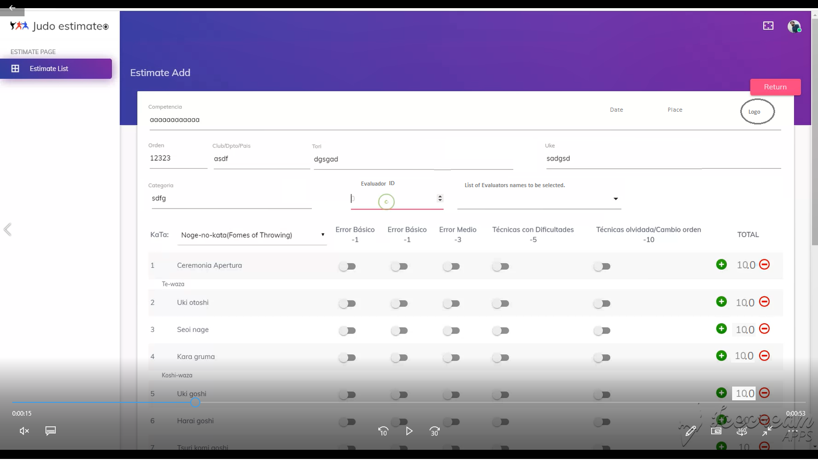

## Fields

Fixed: there are some data fixed for all competitors:

* Tournament: name of the competition
* Logo: an image with the competition logo (*** if possible selected by the admin ***)
* Date: date of the competition
* Place: city where the competition is held

Dynamics: then there are data fields for each specific contestant in the competition:

* Evaluador: name of the judge evaluator and his ID (*** if possible selected from a list ***).
* Order#: ID order given to the pair of contestants to show or present the kata to the judges.
* Club/Dpto/Pais: contestants origin country, state or club
* Tori: name of the first contestant, which executes the techniques throws
* Uke: name of the second contestant, which receives the techniques a perform the falls.
* Categoría: division/category of the kata

Techniques: techniques to be evaluated which are dynamically presented according the kata have between 17 to 25 items to be valued with 10 points, having 5 types of scores for each item (-1, -1, -3, -5, -10), so that an automatic calculation is performed each time a score is checked or unchecked, so the scores can be with a selection control or check box.

Points: for each technique should be awarded an evaluation from 0.0 to 10.0, using decimals. The Point System has

* Total for each technique = 10.0 points
* Forgotten technique = - 10 points and 1/2 of total score
* Big mistake = - 5 points (max of 1)
* Medium mistake = - 3 points (max of 1)
* Small mistake = - 1 point (max of 2)

Adjustments options: Each technique point can be adjusted 0.5 to + or – from the value selecting the errors.

Timer: a clock that take the time of the kata, starting when the evaluator indicates and stops with the last item or technique evaluated.

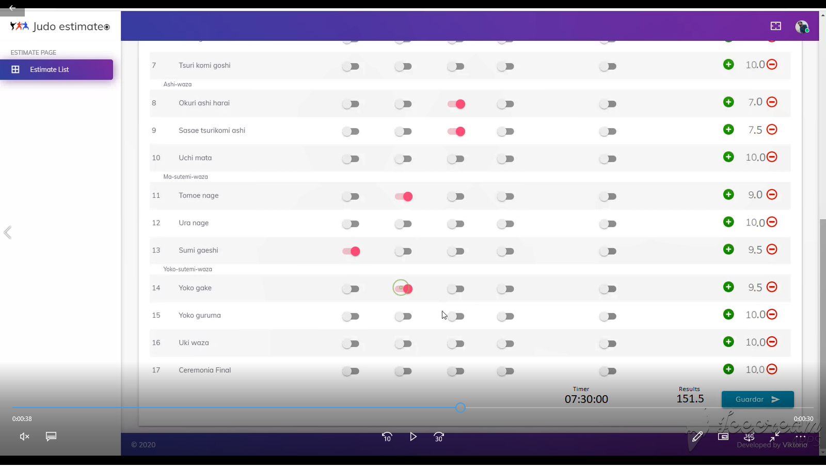

## Features of the Evaluation Form

* Save: each evaluation form can be saved and retrieved later with the same information entered by the evaluator.
* Open: open a previous evaluation for a specific judge.
* Print: be able to print out the form individually (*** just, if possible ***)
* Kata: there is a list with katas available, and for each kata a set of techniques (see the annex).
* Clear: restart the form, remove all the points and starting to evaluate.

## List of Evaluations

A list of the evaluation made showing the main information entries:

* Kata
* Categoría
* Orden#
* Club/Dpto/País
* Tori/Uke
* Judge name
* Total

## Actions

* Add kata: create a new form
* Edit: open for edition a previous eval form
* Delete: remove or mark for deletion (only administrator has access to this option)

## Access Control of competitors to be evaluated

Control the 5 evaluators to access just a specific pair of contestants (Tori/Uke), for instance suppose there are 10 pairs of contestants, so when the first pair is going to present the Kata, the 5 evaluator should access just that contestants from their ID or Names (Tori/Uke), after they finishes to evaluate that presentation and save the results, the administrator thru the dashboard panel can authorize the next contestants to be selected for evaluation.

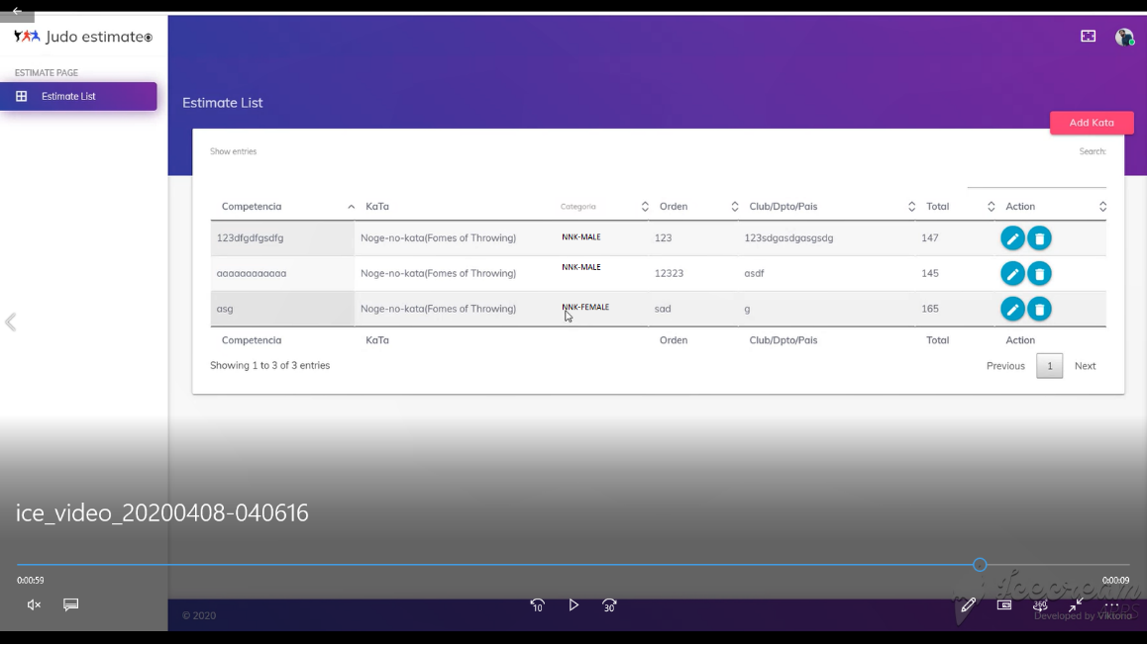

# DASHBOARD

This is the view of the summary results calculation and stats of the tournament of kata.

Each kata result should be calculated from the 5 judges evaluation forms by executing the general result formula of system of judging.

## SYSTEM OF JUDGING

The Judges are five and will be positioned on the jury (showmen) side. They will award points on the official scoring sheet. For each technique the total score of three Judges will be totaled to produce the final score: the maximum score and the minimum score for each technique will be cancelled. The total score of the whole Kata will be the sum of the score totaled by five Judges.

The couple enters and leaves the competition area at the opposite side of showmen: the start and end of Kata (opening and closing ceremony) is at 10 m or 8 m distance (bow to the mat). Any behavior of Tori or Uke inside the Competition area that is contrary to the spirit of Kata will reduce the score of the ceremony.

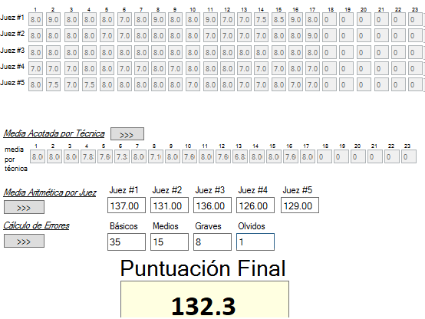

|  |  |  |  |  |  |  |  |  |  |  |  |  |  |  |  |  |  |  |  |  |  |  |  |  |  |
| --- | --- | --- | --- | --- | --- | --- | --- | --- | --- | --- | --- | --- | --- | --- | --- | --- | --- | --- | --- | --- | --- | --- | --- | --- | --- |
| id | Kata | Evaluador | Categoria | Club | TORI | UKE | TOTAL | TIME | T1 | T2 | T3 | T4 | T5 | T6 | T7 | T8 | T9 | T10 | T11 | T12 | T13 | T14 | T15 | T16 | T17 |
| 901 | NnK | 101 | NnK-Masculino | VAL | Jose Arley Moreno | Jeison Fabian Burbano | 137,0 | 0:00:00 | 8,0 | 9,0 | 8,0 | 8,0 | 8,0 | 7,0 | 8,0 | 9,0 | 8,0 | 8,0 | 9,0 | 7,0 | 7,0 | 7,5 | 8,5 | 9,0 | 8,0 |
| 901 | NnK | 102 | NnK-Masculino | VAL | Jose Arley Moreno | Jeison Fabian Burbano | 131,0 | 0:00:00 | 8,0 | 8,0 | 8,0 | 8,0 | 7,0 | 7,0 | 8,0 | 8,0 | 8,0 | 8,0 | 7,0 | 7,0 | 7,0 | 7,0 | 8,0 | 8,0 | 9,0 |
| 901 | NnK | 103 | NnK-Masculino | VAL | Jose Arley Moreno | Jeison Fabian Burbano | 136,0 | 0:00:00 | 8,0 | 8,0 | 8,0 | 8,0 | 8,0 | 8,0 | 8,0 | 8,0 | 8,0 | 8,0 | 8,0 | 8,0 | 8,0 | 8,0 | 8,0 | 8,0 | 8,0 |
| 901 | NnK | 104 | NnK-Masculino | VAL | Jose Arley Moreno | Jeison Fabian Burbano | 126,0 | 0:00:00 | 7,0 | 7,0 | 7,0 | 8,0 | 8,0 | 7,0 | 7,0 | 8,0 | 7,0 | 8,0 | 8,0 | 8,0 | 7,0 | 7,0 | 7,0 | 8,0 | 7,0 |
| 901 | NnK | 105 | NnK-Masculino | VAL | Jose Arley Moreno | Jeison Fabian Burbano | 129,0 | 0:00:00 | 8,0 | 7,5 | 7,0 | 7,5 | 8,0 | 8,0 | 8,0 | 8,0 | 8,0 | 7,0 | 8,0 | 8,0 | 7,0 | 7,0 | 8,0 | 7,0 | 7,0 |
|  |  |  |  |  |  |  |  |  | 8,0 | 7,8 | 7,7 | 8,0 | 8,0 | 7,3 | 8,0 | 8,0 | 8,0 | 8,0 | 8,0 | 7,7 | 7,0 | 7,2 | 8,0 | 8,0 | 7,7 |
|  |  |  |  |  |  |  | 131,8 |  |  |  |  |  |  |  |  |  |  |  |  |  |  |  |  |  | 132,3 |

## WIDGETS

In this view the user can select the information to be displayed:

* Total of participants (gender, country/club, type of kata)
* Results by category (top 5)
* Results by kata (top 5)
* Individual Results (total points)
* Total of errors (by category, by kata, by individual)
* Judges evaluation scores (totals, media, variant)

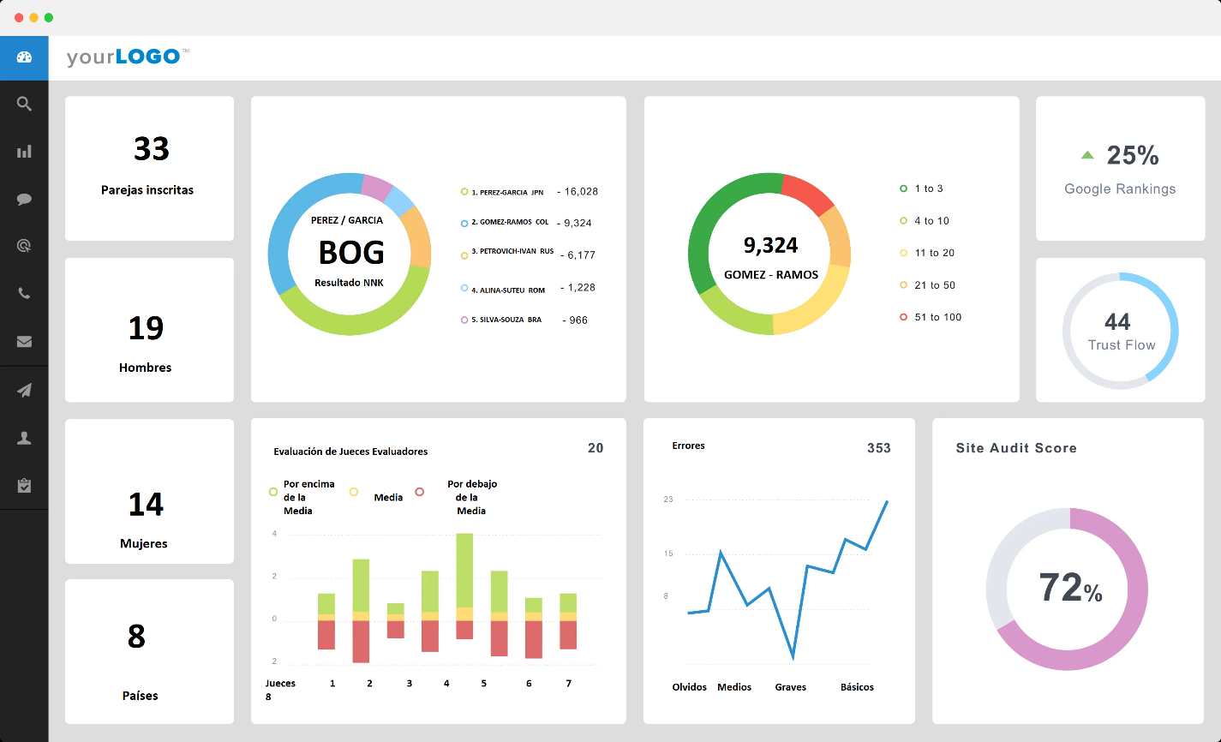

## KATAS

Nage No Kata

---------------------

01.-Ceremonia apertura

Te waza:

02.- Uki otoshi

03.- Seoi nage

04.- Kata guruma

Koshi-waza:

05.- Uki goshi

06.- Harai goshi

07.- Tsuri komi goshi

Ashi-waza:

08.- Okuri ashi harai

09.- Sasae tsuri komi ashi

10.- Uchi mata

Ma-sutemi-waza:

11.- Tomoe nage

12.- Ura nage

13.- Sumi gaeshi

Yoko-sutemi-waza:

14.- Yoko gake

15.- Yoko guruma

16.- Uki waza

17.-Ceremonia final

KATAME–NO–KATA

----------------------

01.-Ceremonia apertura

OSAE-KOMI-WAZA

02.- Kesa-gatame

03.- Kata-gatame

04.- Kami-shiho-gatame

05.- Yoko-shiho-gatame

06.- Kuzure-kami-shiho-gatame

2) SHIME-WAZA

07.- Kata-juji-jime

08.- Hadaka-jime

09.- Okuri-eri-jime

10.- Kata-ha-jime

11.- Gyaku-juji-jime

KANSETSU-WAZA

12.- Ude-garami

13.- Ude-hishigi-Juji-gatame

14.- Ude-hishigi-Ude-gatame

15.- Ude-hishigi-Hiza-gatame

16.- Ashi-garami

17.-Ceremonia final

Kime no Kata

---------------------------------

01.-Ceremonia apertura

1) Idori

02.- 1. Ryote-dori (Two-Hand Hold)

03.- 2. Tsukkake (Stomach Punch)

04.- 3. Suri age (Forehead Thrust)

05.- 4. Yoko uchi (Side Blow)

06.- 5. Ushiro-dori (Hold from behind)

07.- 6. Tsukkomi (Dagger Thrust to Stomach)

08.- 7. Kirikomi (Downward Slash)

09.- 8. Yoko tsuki (Dagger Thrust to Side)

2) Tachiai

10.- 1. Ryote-dori (Two-Hand Hold)

11.- 3. Tsuk-kake (Punch to Face)

12.- 4. Tsukiage (Uppercut)

13.- 5. Suri Age (Forehead Thrust)

14.- 8. Ushiro-dori (Hold from Behind)

15.- 9. Tsukkomi (Dagger Thrust to Stomach)

16.- 10. Kirikomi (Downward Slash)

17.- 11. Nuki kake (Sword Unsheathing)

18.- 12. Kirioroshi (Downward Cut)

19.- Closing Movements

Goshin Jutsu No Kata

----------------------------

01.-Ceremonia apertura

Unarmed Close-in Attacks by Holding

02.- Ryote dori – two hand hold

03.- Hidari eri dori – left lapel hold

04.- Migi eri dori – right lapel hold

05.- Kata ude dori – single hand hold

06.- Ushiro eri dori – back collar hold

07.- Ushiro jime – rear choke

08.- Kakae dori – rear seizure

Unarmed Attack at a Distance

09.- Naname uchi – slanting strike

10.- Ago tsuki – uppercut

11.- Gammen tsuki – thrust punch or jab

12.- Mae geri – front kick

13.- Yoko geri – side kick

Armed Attack – Knife

14.- Tsukkake – close in thrust

15.- Choku zuki – straight thrust

16.- Naname zuki – slanting stab

Armed Attack – Stick

17.- Furiage – upswing against a stick

18.- Furioroshi – downswing against a stick

19.- Morote zuke – two hand thrust

Armed Attack – Gun

20.- Shomen zuke – pistol held to abdomen

21.- Koshi gamae – pistol at side

22.- Haimen zuke – pistol against the back

23.-Ceremonia final